**1. Questions 1 to 5 refer to the following scenario:**

**Suppose a binary classifier produced the following confusion matrix.**

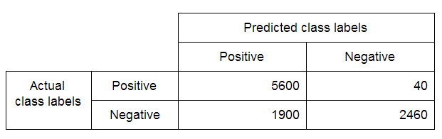

**What is the accuracy of this classifier? Round your answer to 2 decimal places.**

0.81

**2. Refer to the scenario presented in Question 1 to answer the following:**

**(True/False) This classifier is better than random guessing.**

**True**

False

**3. Refer to the scenario presented in Question 1 to answer the following:**

**(True/False) This classifier is better than the majority class classifier.**

**True**

False

**4. Refer to the scenario presented in Question 1 to answer the following:**

**Which of the following points in the precision-recall space corresponds to this classifier?**

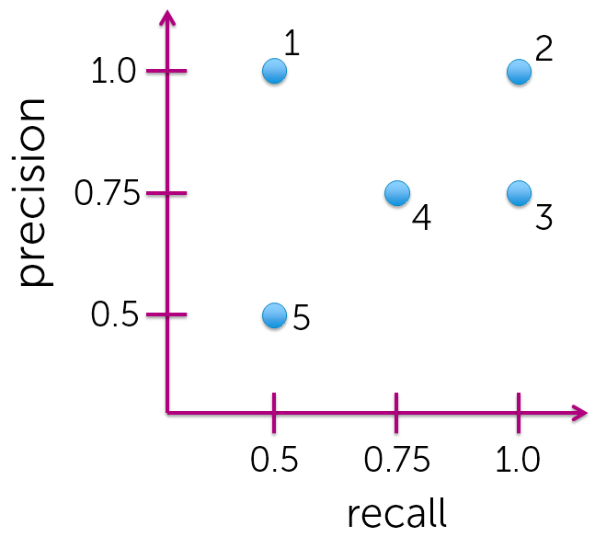

(1)

(2)

**(3)**

(4)

(5)

**5. Refer to the scenario presented in Question 1 to answer the following:**

**Which of the following best describes this classifier?**

It is optimistic

It is pessimistic

**None of the above**

**It is optimistic**

It is pessimistic

None of the above

**6. Suppose we are fitting a logistic regression model on a dataset where the vast majority of the data points are labeled as positive. To compensate for overfitting to the dominant class, we should**

Require higher confidence level for positive predictions

**Require lower confidence level for positive predictions**

**Require higher confidence level for positive predictions**

Require lower confidence level for positive predictions

**7. It is often the case that false positives and false negatives incur different costs. In situations where false negatives cost much more than false positives, we should**

**Require higher confidence level for positive predictions**

Require lower confidence level for positive predictions

Require higher confidence level for positive predictions

**Require lower confidence level for positive predictions**

**8. We are interested in reducing the number of false negatives. Which of the following metrics should we primarily look at?**

Accuracy

Precision

**Recall**

**9. Suppose we set the threshold for positive predictions at 0.9. What is the lowest score that is classified as positive? Round your answer to 2 decimal places.**

2.19